Body fat is considered to be a helpful and powerful indicator of fitness. However, measuring exact body fat is too complicated. In this project, we use the data set obtained from a study of 252 men with body fat percentage and all other body measurements data included. The body fat percentage (density) of the men was calculated with volumes, which was measured by submerging men in water. Therefore, the goal of this project is to find a simple but accurate method to estimate the body fat by using body circumference measurement

**Data Cleaning***（Nan Yang）*

Based on the summary of dataset and distribution of each variable, there are several outliers in Weight, Height and BodyFat data. Considering the accuracy and preciseness of the data, we finally removed these unreasonable values including a 350 pounds man, a 29.5`` tall man and a man with 0% body fat.

**Choosing the best predictor** (*Crystal Liu*)

To determine the best predictor, we built a multiple linear regression model with all variables and then checked the p-values from the summary. We found that abdominal circumference has the most significant p-value (2.2 ∗ 10−16), which means the changes in predictor value are significantly associated with the changes in response value. Also, the R2 value (0.6725) for abdominal circumference is also the largest one of all variables, which means the abdomen explains about 67.25% of all variation in body fat. A scatter plot also shows a good linearity. Therefore, we chose abdominal circumference as our predictor.

**The SLR Model** *(Crystal Liu, Nan Yang)*

After data cleaning, we built the simple regression linear model using body fat as a dependent variable and abdomen circumference as an independent variable.

Our SLR Model of using abdominal circumferences to predict body fat percentage is:

**body fat(%) = -37.991 + 0.616*abdominal circumference(cm)**

The possible Rule of thumb is:

**multiply abdominal circumference(cm) by 0.6 and then subtract by 38cm**.

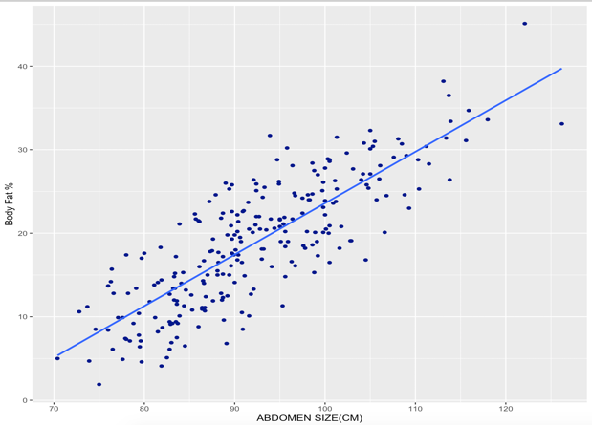

For example, for a male with abdomen circumference of 100 cm, his predicted body fat % percentage would be around 23.60%. There is a 95% probability that his body fat is between 14.98% and 32.21%. Every increase of 1 cm in abdomen size, men gain, on average, 0.616% of body fat %.

The rule of thumb is little underestimated our estimated model because we decrease the slope to 0.6, which means to obtain the same body fat percentage, larger abdomen size will be added.

However, this rule of thumb is still reasonable because the 95% confidence interval for slope and intercept in this model are (0.562, 0.670) and (-43.0, -33.0). The approximate slope (0.6) and intercept (-38) are still in the 95% confidence interval.

**Hypothesis Test**

H0: β1 = 0; Ha: β1 ≠ 0

The p-value, 2.2 ∗ 10−16, is much smaller than the 5% significant level. Therefore, we can reject the null hypothesis and conclude there is enough evidence showing that there is linear relationship between body fat percentage and abdominal circumferences. Based on the graph above, the linear relationship should be positive. As the abdominal circumference increases, the body fat percentage increases as well.

**Strengths and weaknesses of the model** *(Sukyoung Cho)*

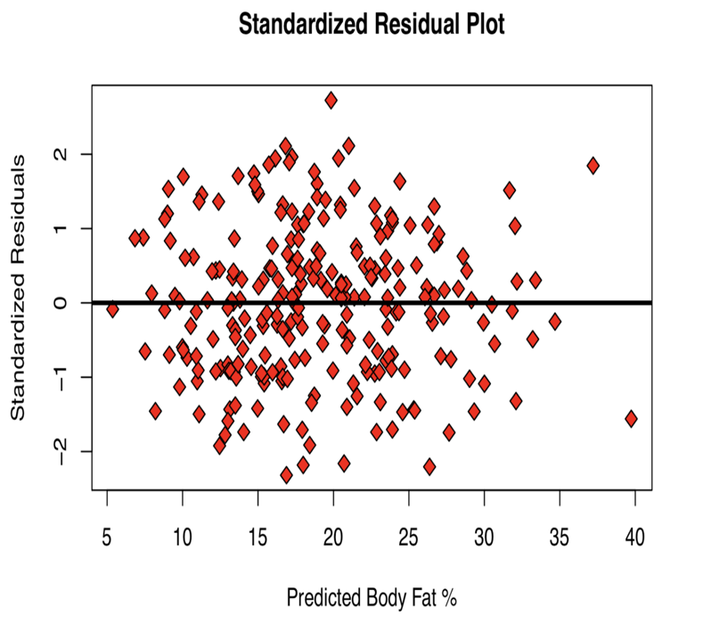

**Strengths:**

●     Linearity: reasonable based on both the scatter plot and residual plot (shown on the right)

●     Additivity: it is reasonable to infer that an increase in abdominal circumference would result in higher body fat percentage. Except for children who have not undergone their growth spurt.

●     Homoscedasticity: based on the residual plot, the variability seems to be constant

●     Constant effects: reasonable in general but may have some exceptions such as rapid growth. A skinnier man would have bigger abdominal size after working out, but not necessarily have higher body fat percentage.

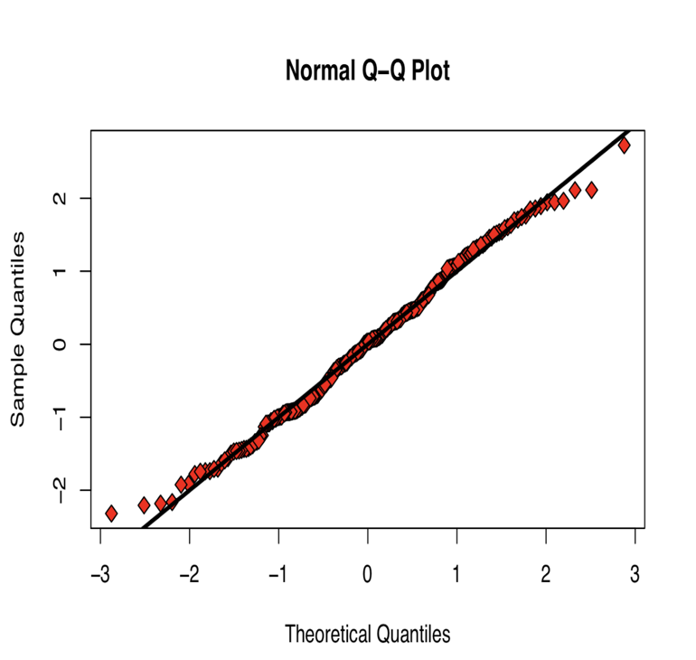

**Weaknesses:**

●     Errors are not perfectly normally distributed: In our Q-Q plot (shown on the right), the points display a curve pattern along the line and a few points off the line at the ends. As our residual plot exhibits a good linearity, those small variations are not likely to be critical.

●     Accuracy: Since our model only explains 67.25% of variation in body fat percentage, our prediction intervals would not be very accurate.

●     Inflexibility: As our model is based on the grown men, it can only be used to predict body fat percentage of adult men - inaccurate for women or children.

**Use of the Model**

An adult man could predict his body fat percentage with our “rule-of thumb” based on a recent change in his abdominal circumference. For example, a man who gains 5 cm in abdominal circumference can assume that his body fat percentage has increased by 3%.

**Conclusion**

Although our model does not offer an exact prediction, it suggests a simple but pretty precise rule of thumb for estimating body fat. It is a simple linear relationship which anyone can understand, and the measurement can be easily obtained using a tape. Our prediction is not perfectly precise. However, it holds the assumptions for a SLR model quite well. Moreover, our rule of thumb is within the 95% confidence interval, which is simple, accurate and robust.

References:

Bailey, Covert (1994). _Smart Exercise: Burning Fat, Getting Fit_, Houghton-Mifflin Co., Boston, pp. 179-186.

Behnke, A.R. and Wilmore, J.H. (1974). _Evaluation and Regulation of Body Build and Composition_, Prentice-Hall, Englewood Cliffs, N.J.

Siri, W.E. (1956), "Gross composition of the body", in _Advances in Biological and Medical Physics_, vol. IV, edited by J.H. Lawrence and C.A. Tobias, Academic Press, Inc., New York.

Katch, Frank and McArdle, William (1977). _Nutrition, Weight Control, and Exercise_, Houghton Mifflin Co., Boston.

Wilmore, Jack (1976). _Athletic Training and Physical Fitness: Physiological Principles of the Conditioning Process_, Allyn and Bacon, Inc., Boston.